Experiment 40: Draw Rectangular Shape and Extract Objects
Software / Tools: Python · OpenCV (cv2)

AIM
To draw a rectangle around a region of interest (ROI) in an image and extract (crop out) that object from the image.
ALGORITHM
1. Import OpenCV.
2. Read the input image.
3. Define the rectangle's top-left coordinates (x, y) and its width and height.
4. Draw the rectangle on a copy of the image using cv2.rectangle() to mark the region of interest.
5. Extract the same region from the original image using array slicing: roi = img[y:y+h, x:x+w].
6. Display and save both the marked image and the extracted object.
PROGRAM (SOURCE CODE)
import cv2

img = cv2.imread("image.jpg")

x, y, w, h = 90, 145, 150, 180 # region of interest

# Draw rectangle on a copy to mark the ROI
marked = img.copy()
cv2.rectangle(marked, (x, y), (x + w, y + h), (0, 0, 255), 3)

# Extract (crop) the object using slicing
extracted_object = img[y:y + h, x:x + w]

cv2.imwrite("extracted_object.jpg", extracted_object)
cv2.imshow("Marked Image", marked)
cv2.imshow("Extracted Object", extracted_object)
cv2.waitKey(0)
cv2.destroyAllWindows()

OUTPUT
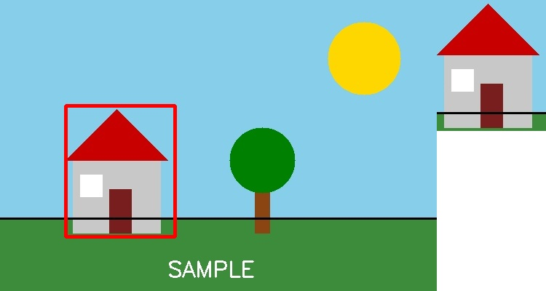
Fig. 40 — Output of Experiment 40: Draw Rectangular Shape and Extract Objects.
RESULT
Draw a rectangle around a region of interest (ROI) in an image and extract (crop out) that object from the image — completed successfully, as demonstrated in the output shown above.

